**MongoDB Task - 1 For the following question write the corresponding MongoDB queries**

For the following question write the corresponding MongoDB queries

1. Find all the information about each product

db.products.find({});

2. Find the product price which is between 400 to 800

db.products.find({ product_price: { $gte: 400, $lte: 800 } });

3. Find the product price which is not between 400 to 600

db.products.find({ product_price: { $not: { $gte: 400, $lte: 600 } } });

4. List the four products which are greater than 500 in price

db.products.find({ product_price: { $gt: 500 } }).limit(4);

5. Find the product name and product material of each product

db.products.find({}, { product_name: 1, product_material: 1, _id: 0 });

6. Find the product with a row id of 10

db.products.find({ id: "10" });

7. Find only the product name and product material

db.products.find({}, { product_name: 1, product_material: 1, _id: 0 });

8. Find all products which contain the value of "Soft" in product material

db.products.find({ product_material: "Soft" });

9. Find products which contain product color "indigo" and product price 492.00

db.products.find({ product_color: "indigo", product_price: 492.00 });

10. Delete the products which have a product price value of 28

db.products.deleteMany({ product_price: 28 });

1.Find all the information about each products

**MongoDB Compass Execution:**

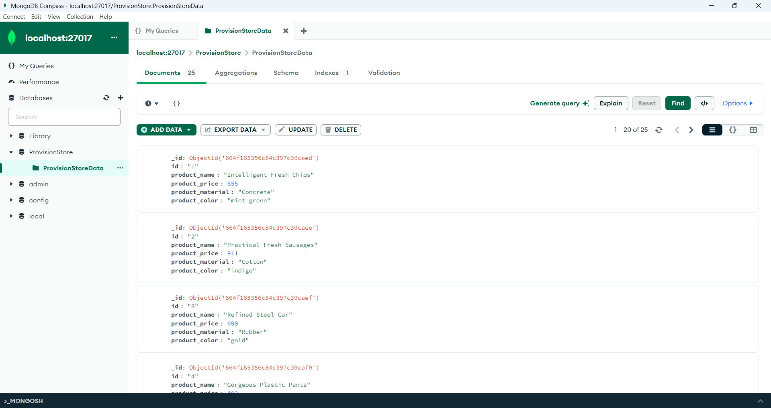

**Shell Execution:**

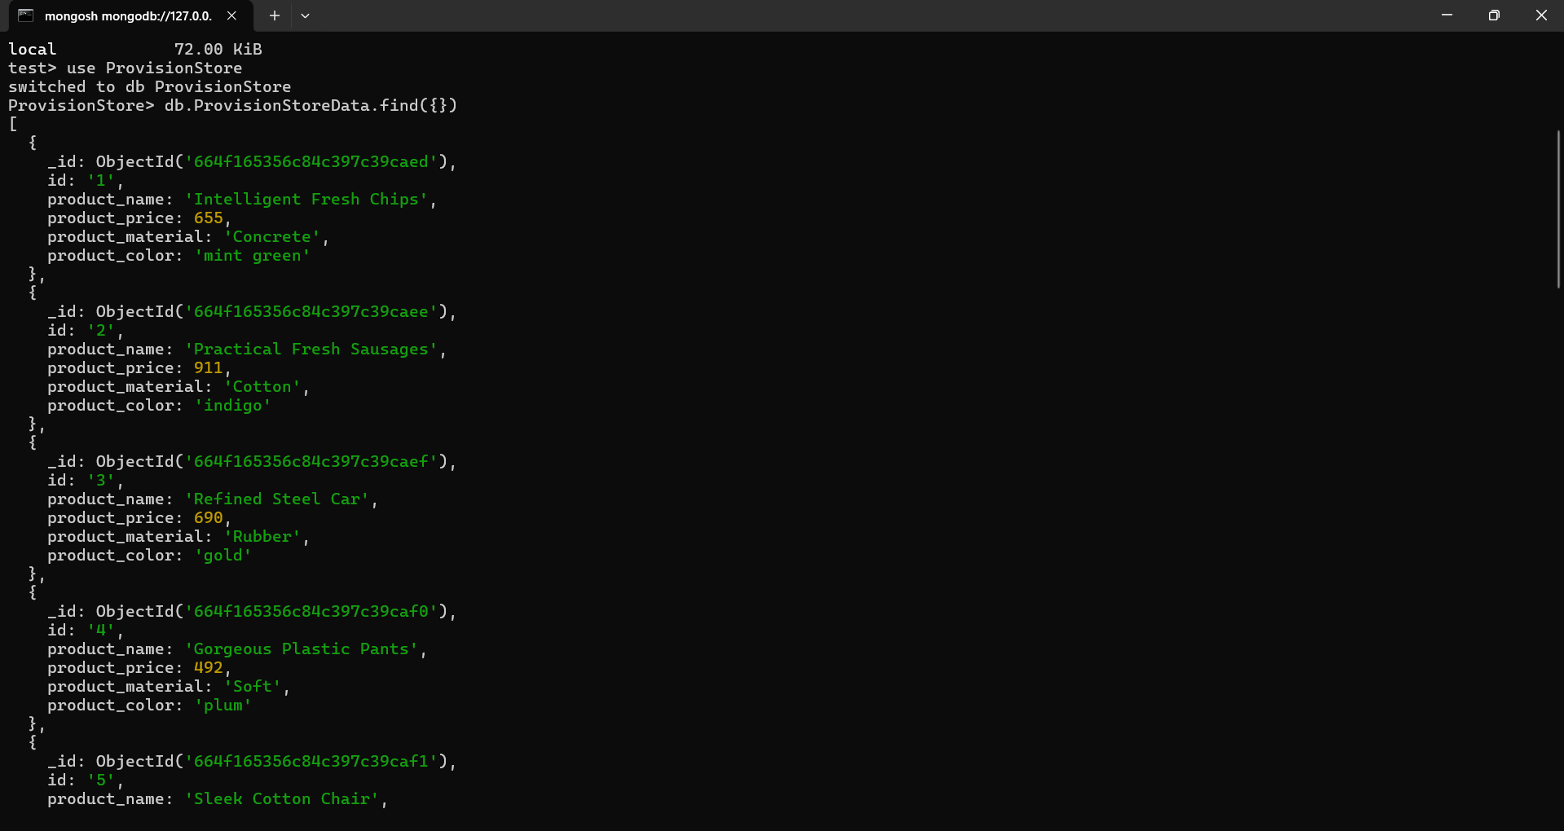

2.Find the product price which are between 400 to 800

**MongoDB Compass Execution:**

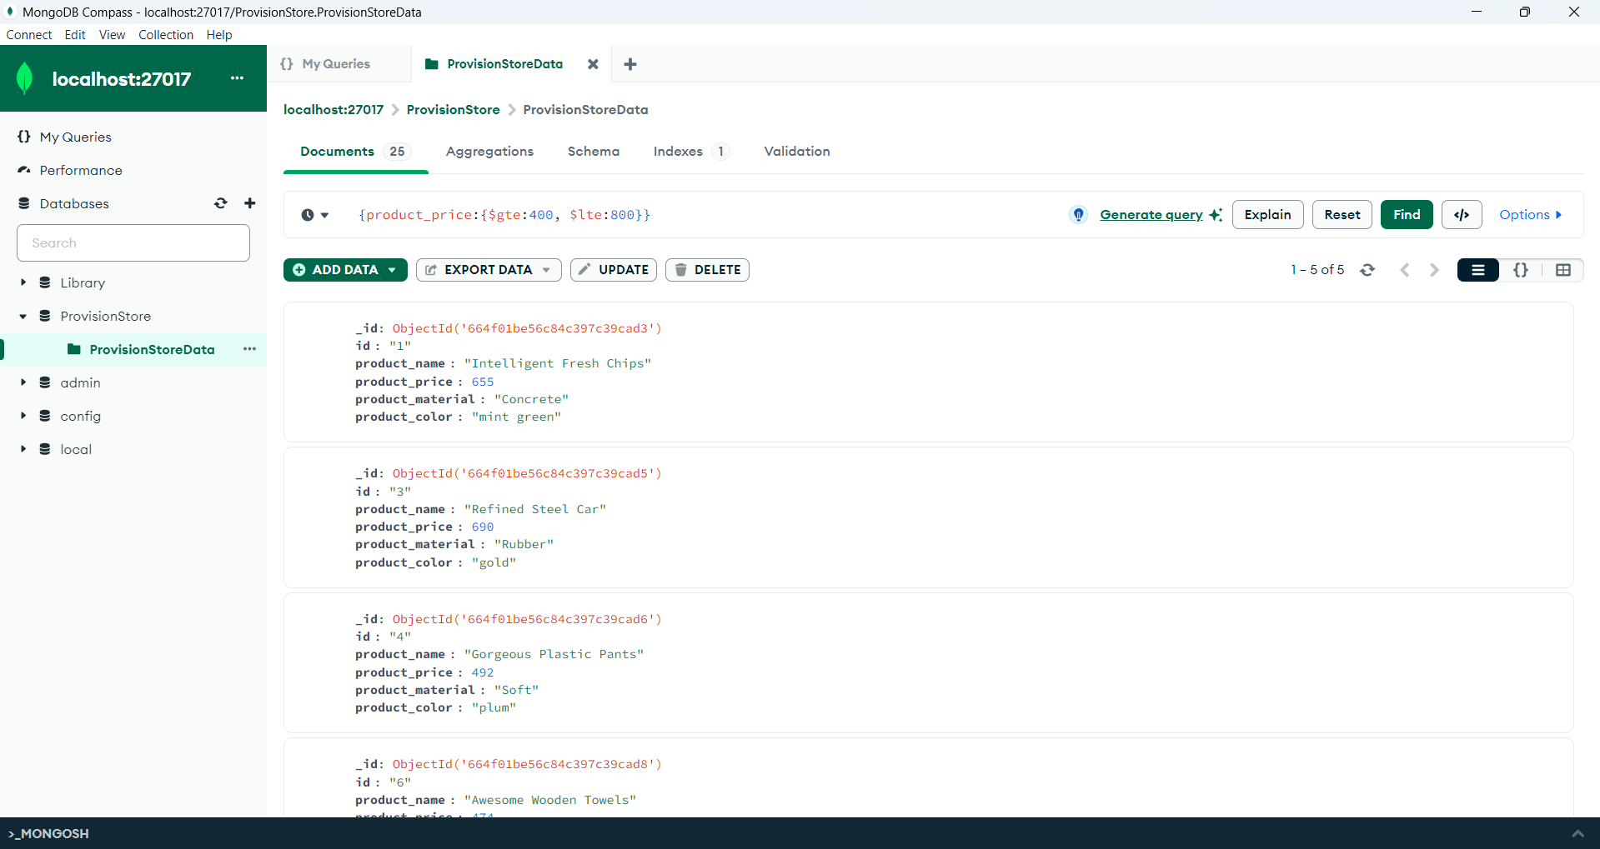

**Shell Execution:**

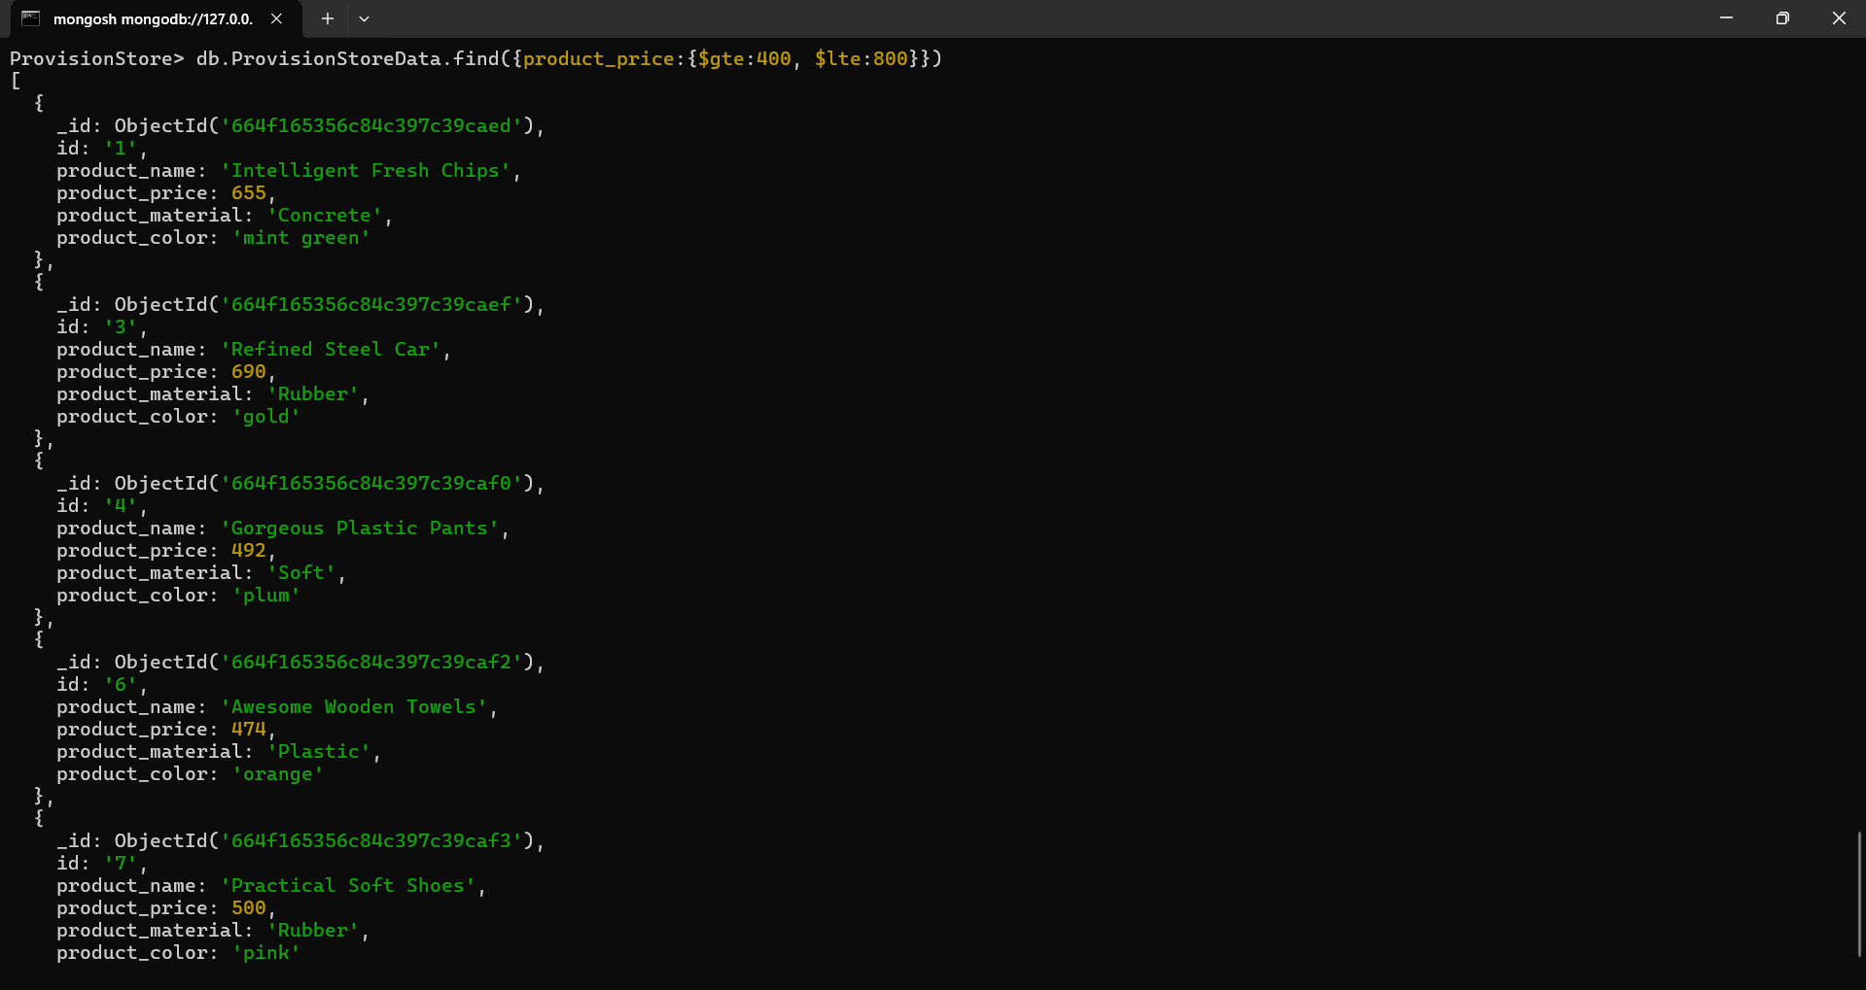

3.Find the product price which are not between 400 to 600

**MongoDB Compass Execution:**

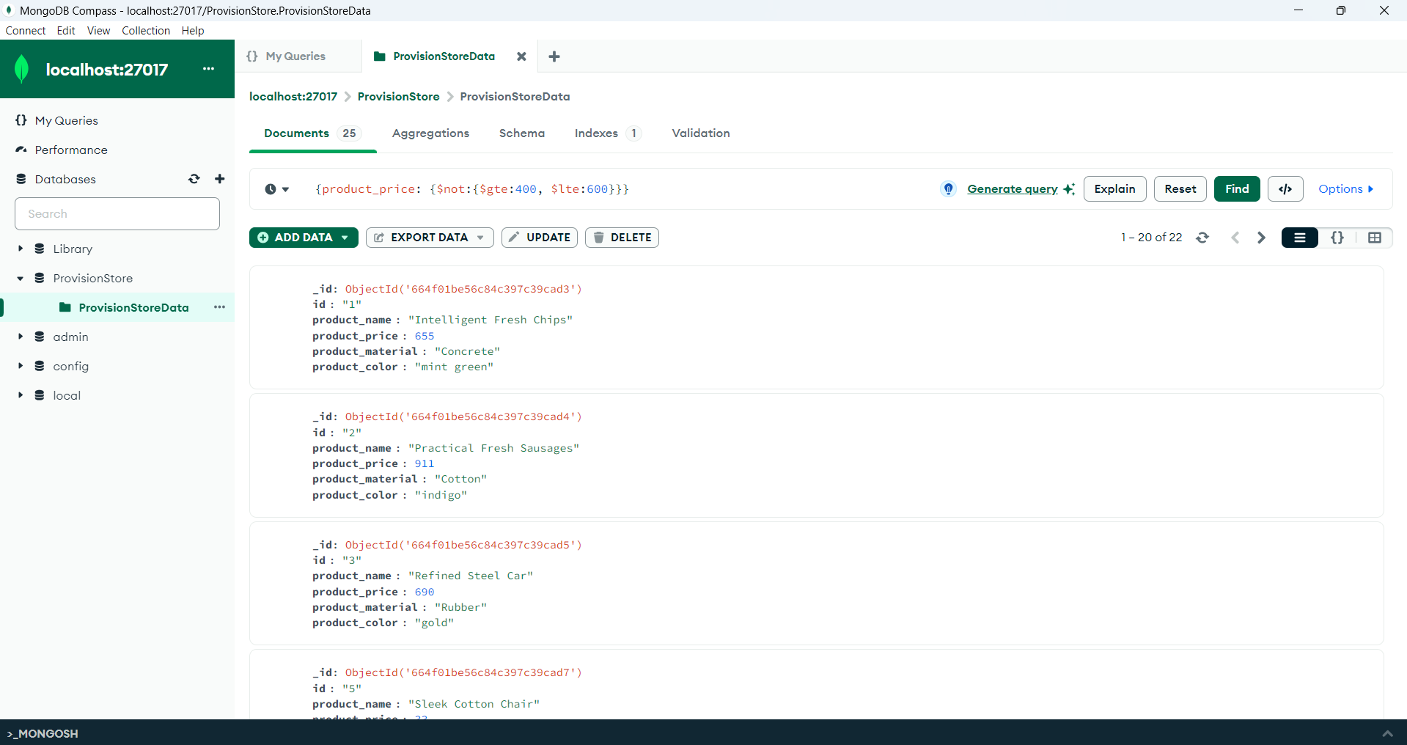

**Shell Execution:**

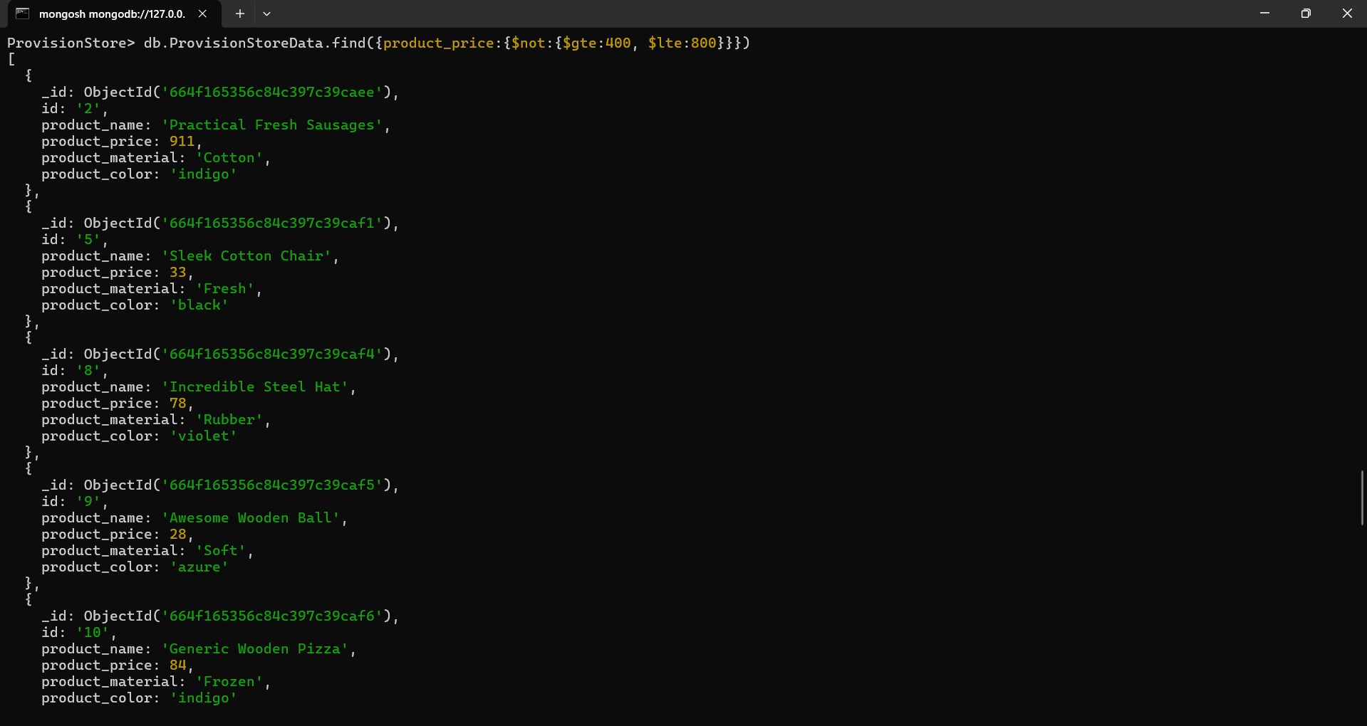

4.List the four product which are greater than 500 in price

**MongoDB Compass Execution:**

**Greater Than 500:**

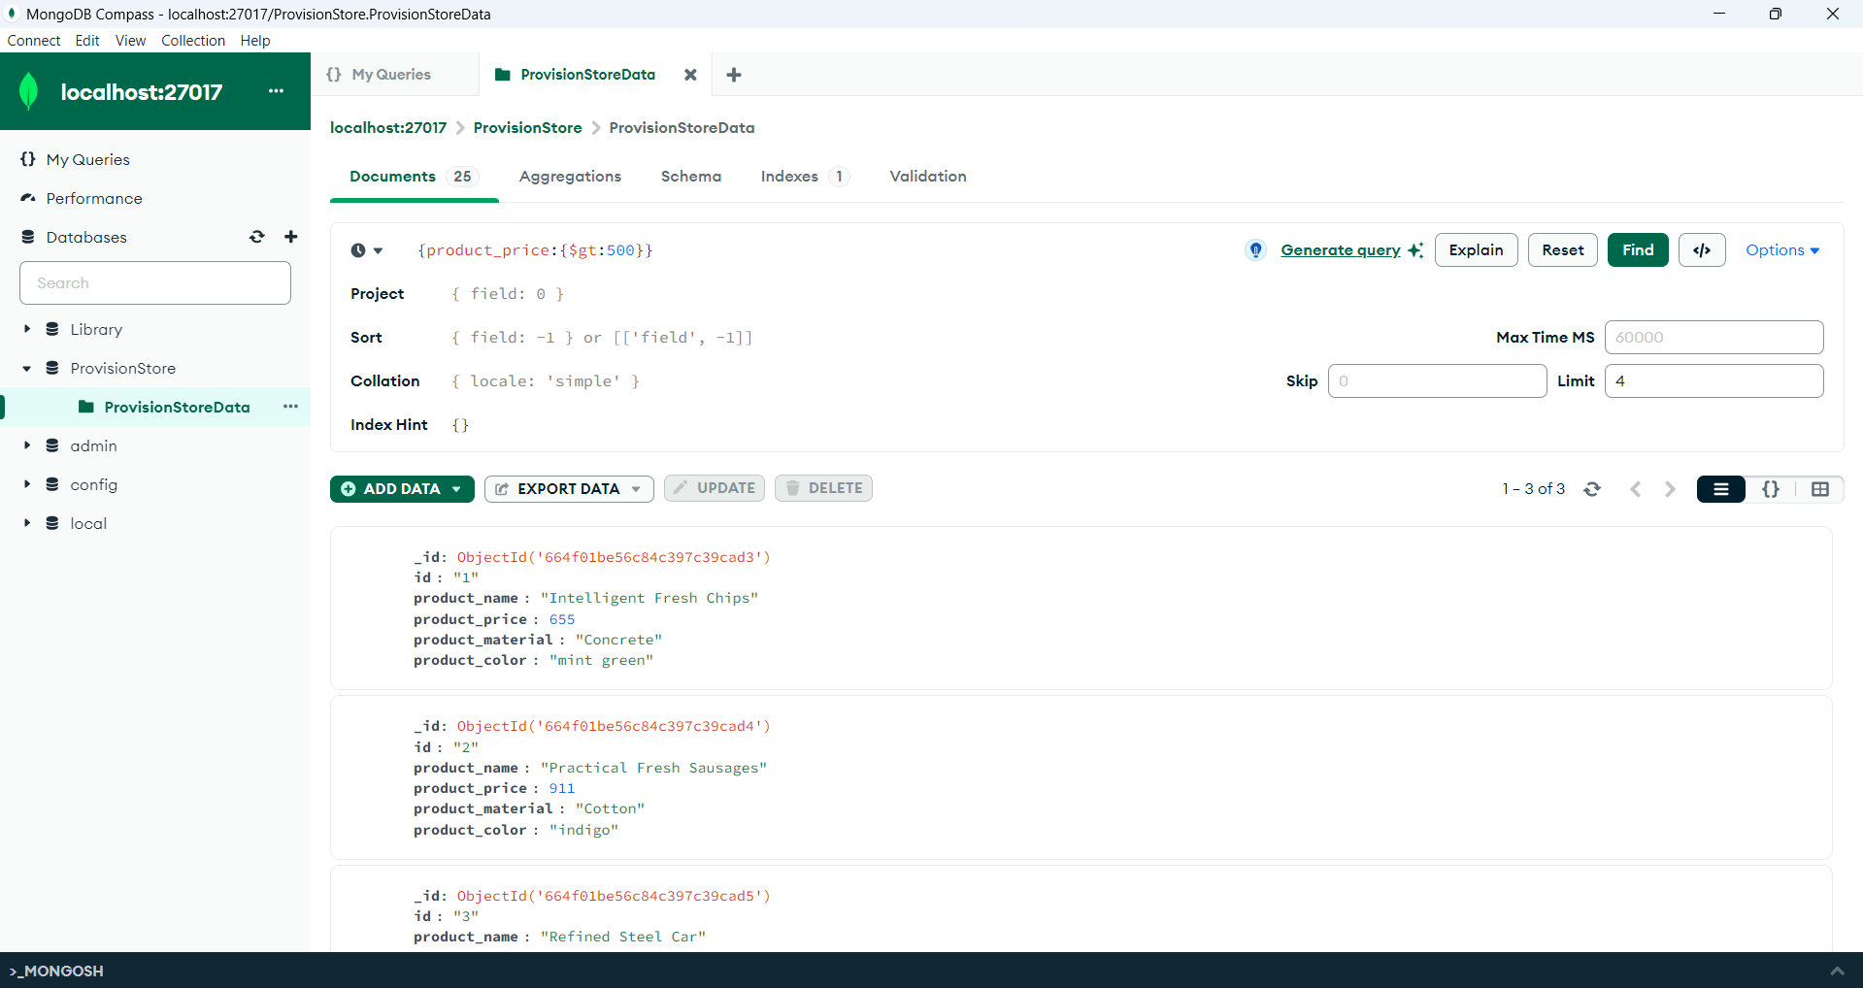

**Greater Than or Equal To 500:**

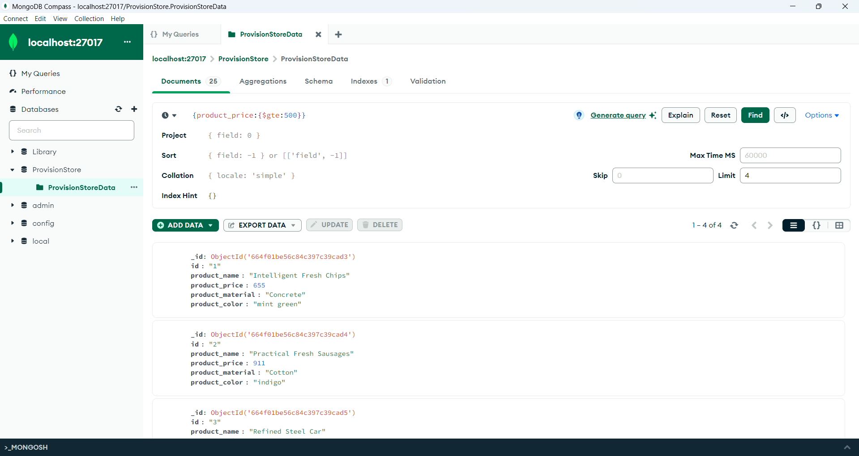

**Shell Execution:**

**Greater Than 500:**

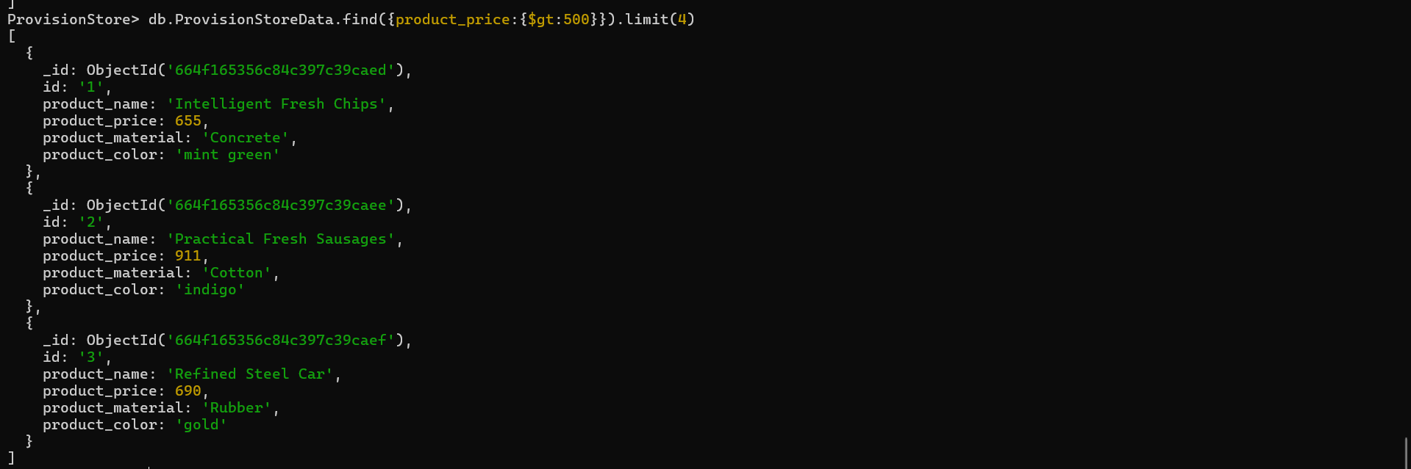

**Greater Than or Equal To 500:**

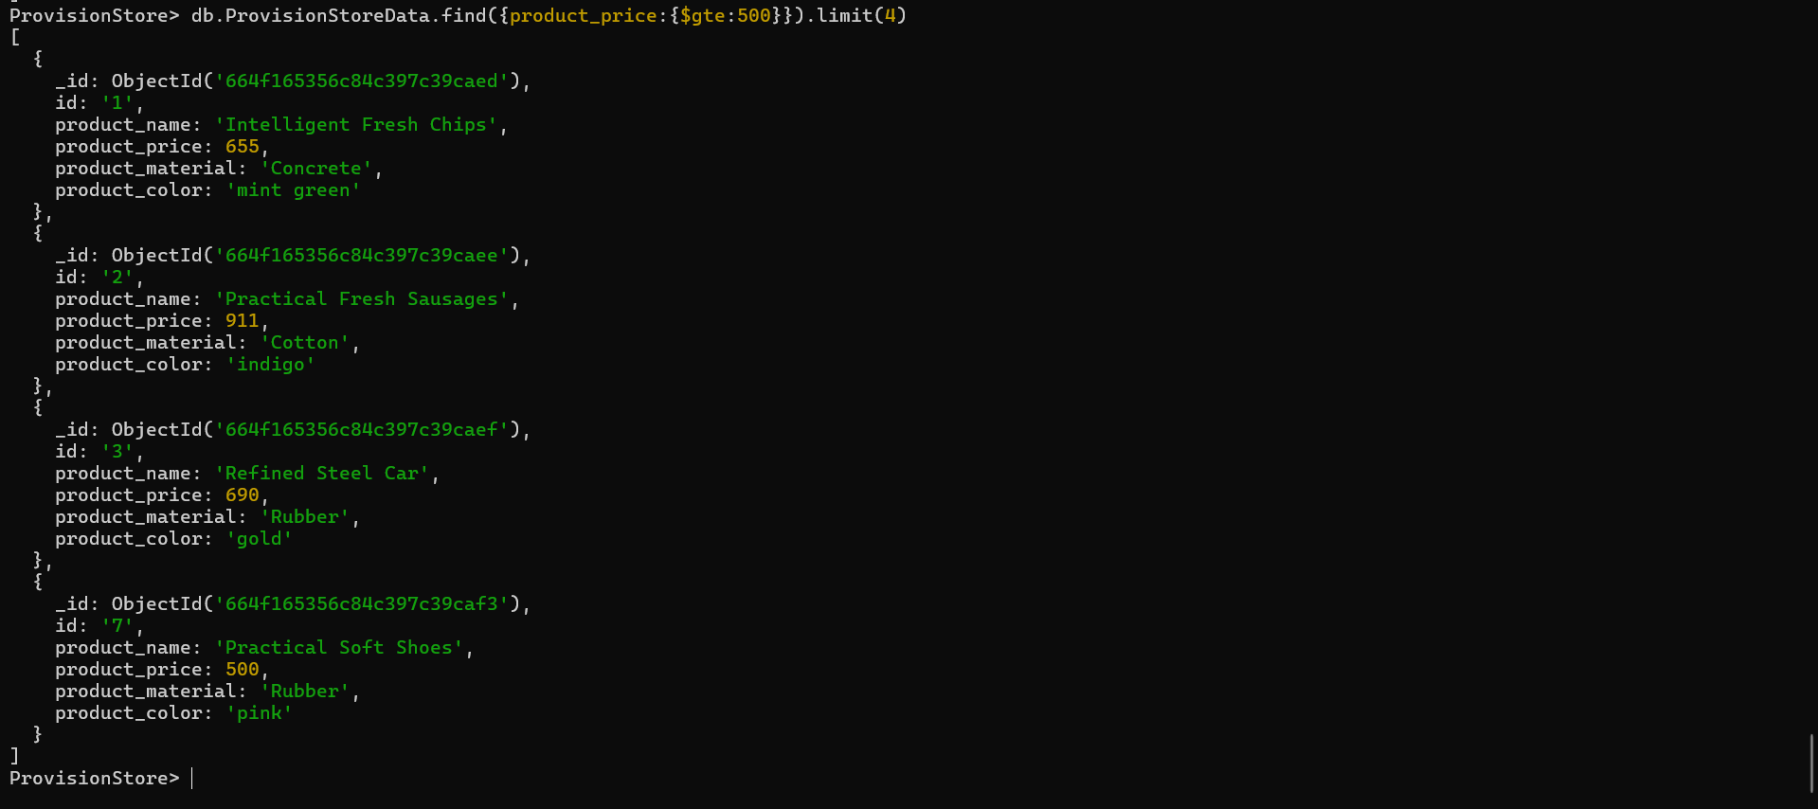

5.Find the product name and product material of each products

**MongoDB Compass Execution:**

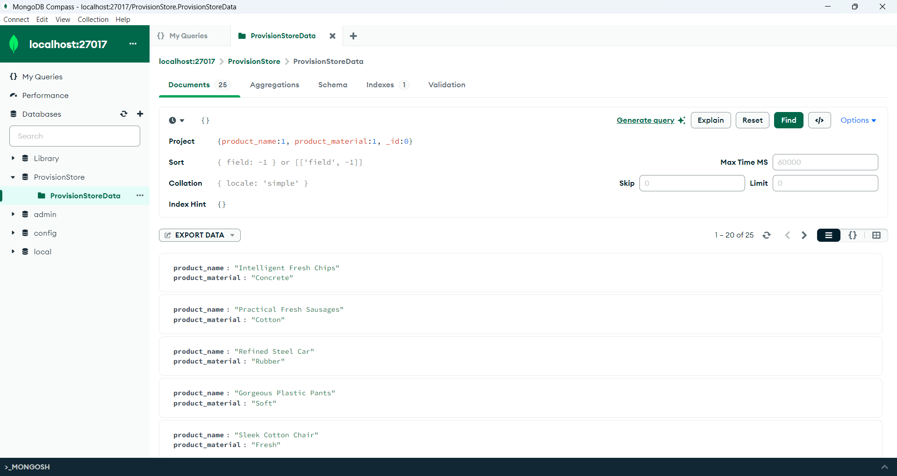

**Shell Execution:**

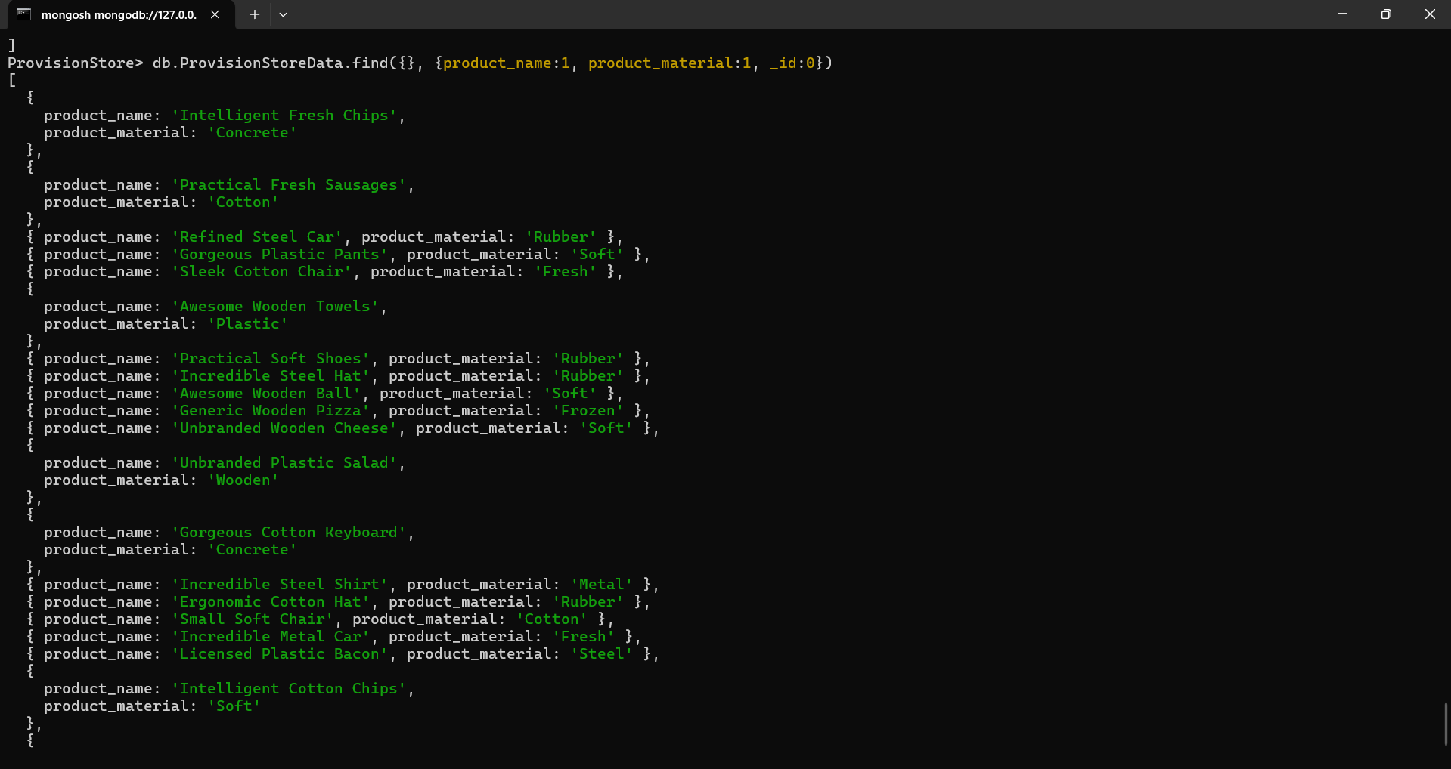

6.Find the product with a row id of 10

**MongoDB Compass Execution:**

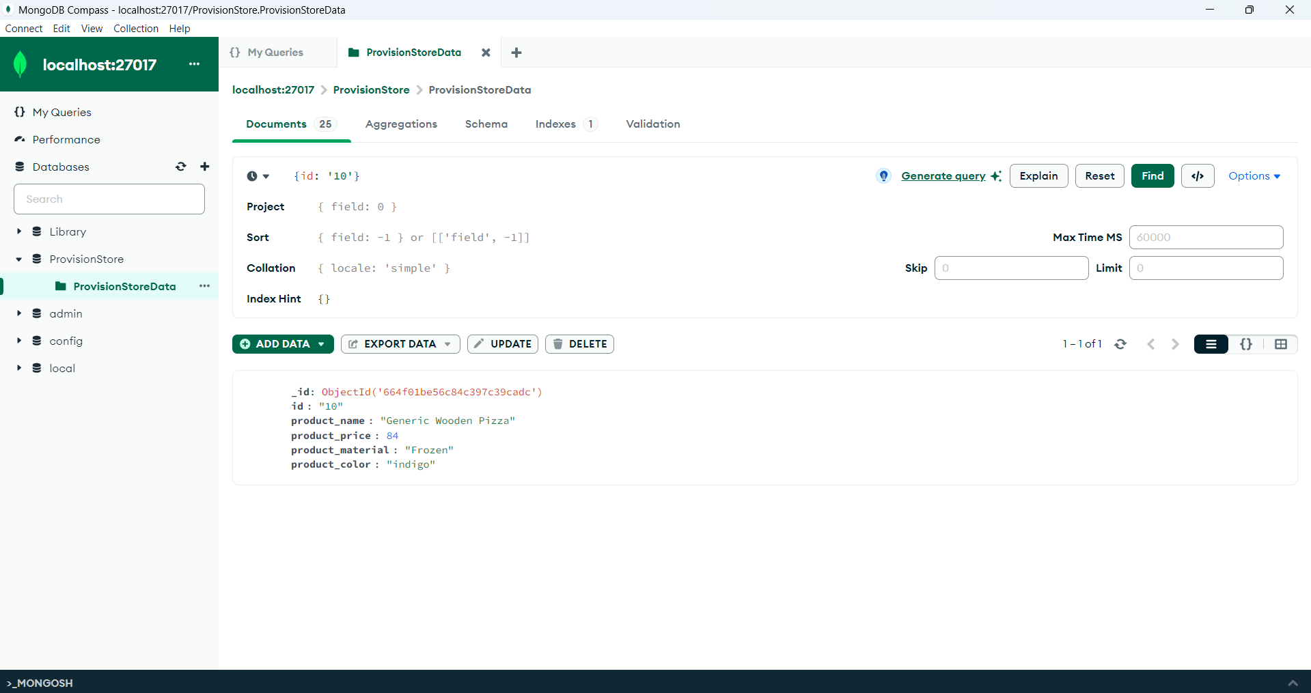

**Shell Execution:**

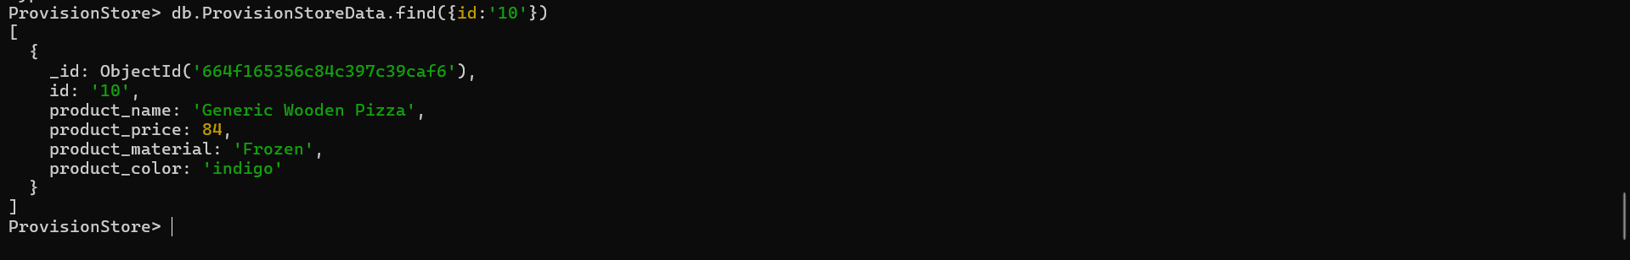

7.Find only the product name and product material

**MongoDB Compass Execution:**

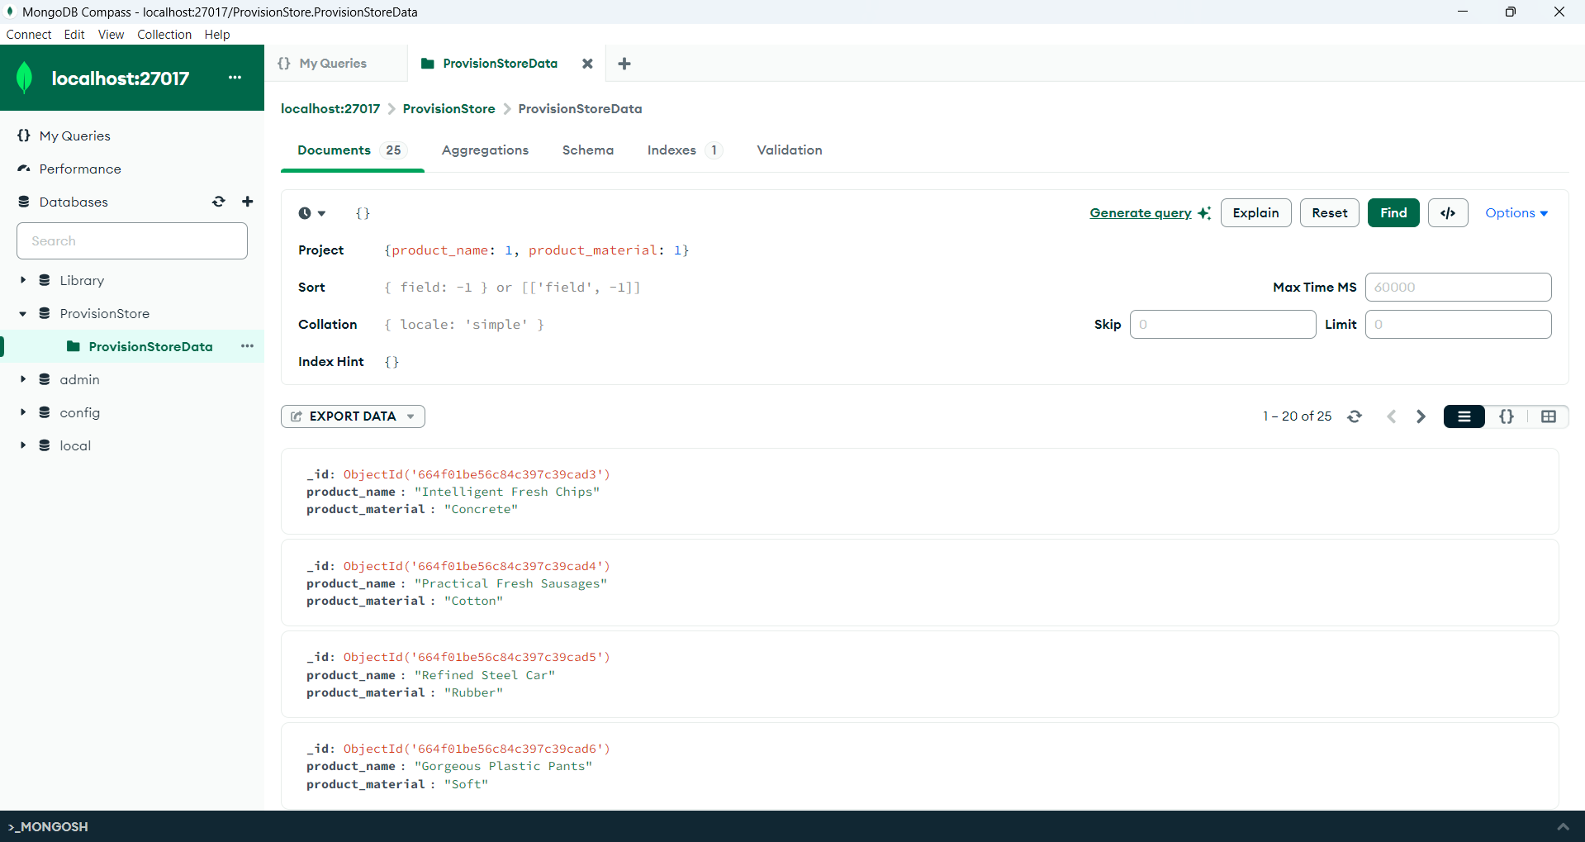

**Shell Execution:**



8.Find all products which contain the value of soft in product material

**MongoDB Compass Execution:**

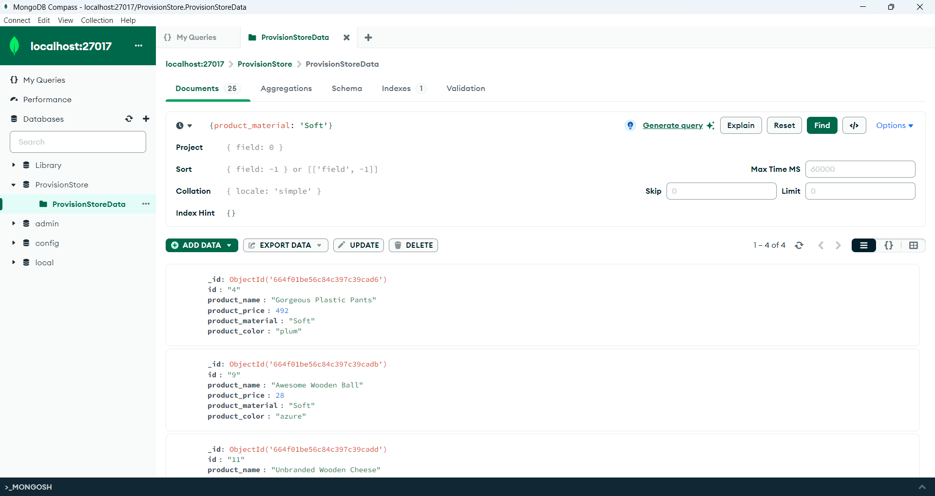

**Shell Execution:**

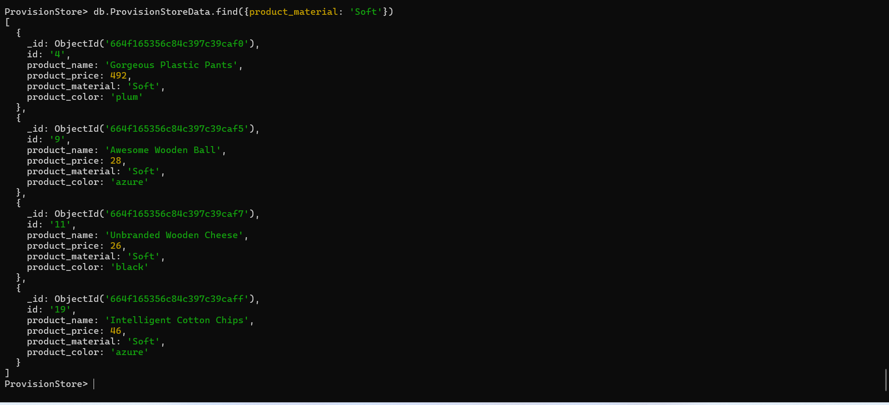

9.Find products which contain product color indigo and product price 492.00

**MongoDB Compass Execution:**

product color indigo

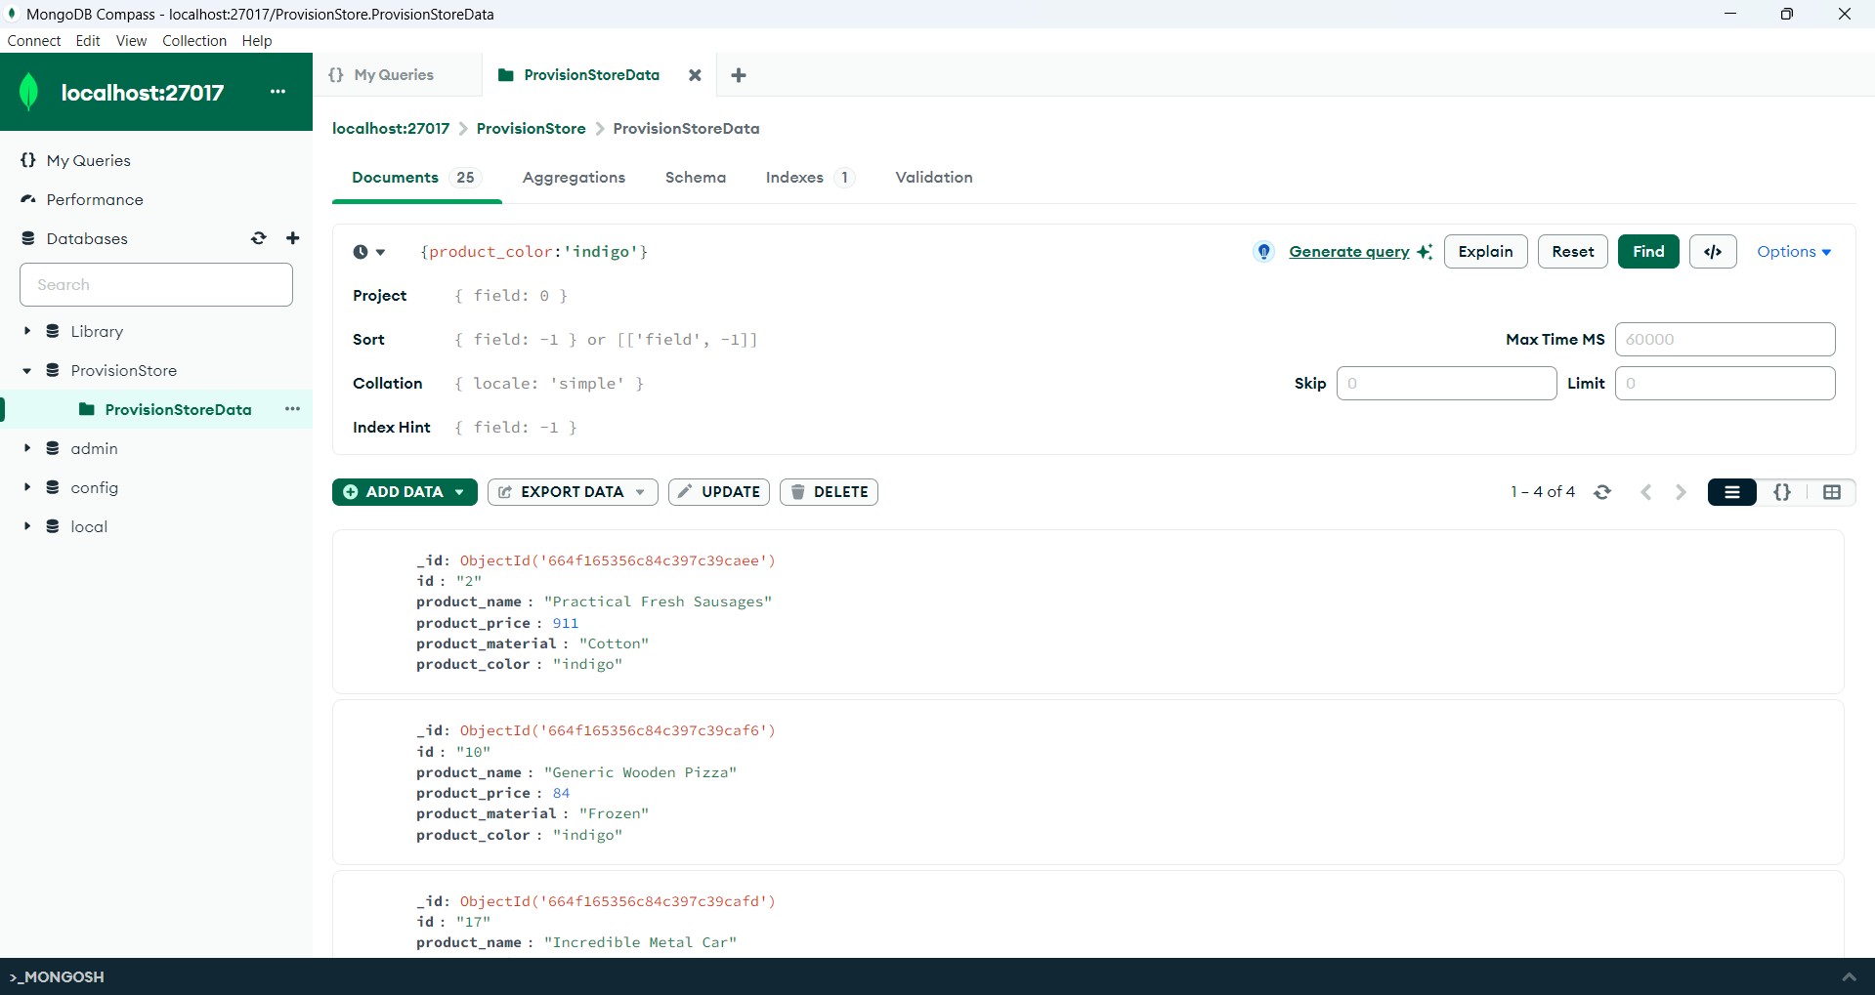

product price 492.00

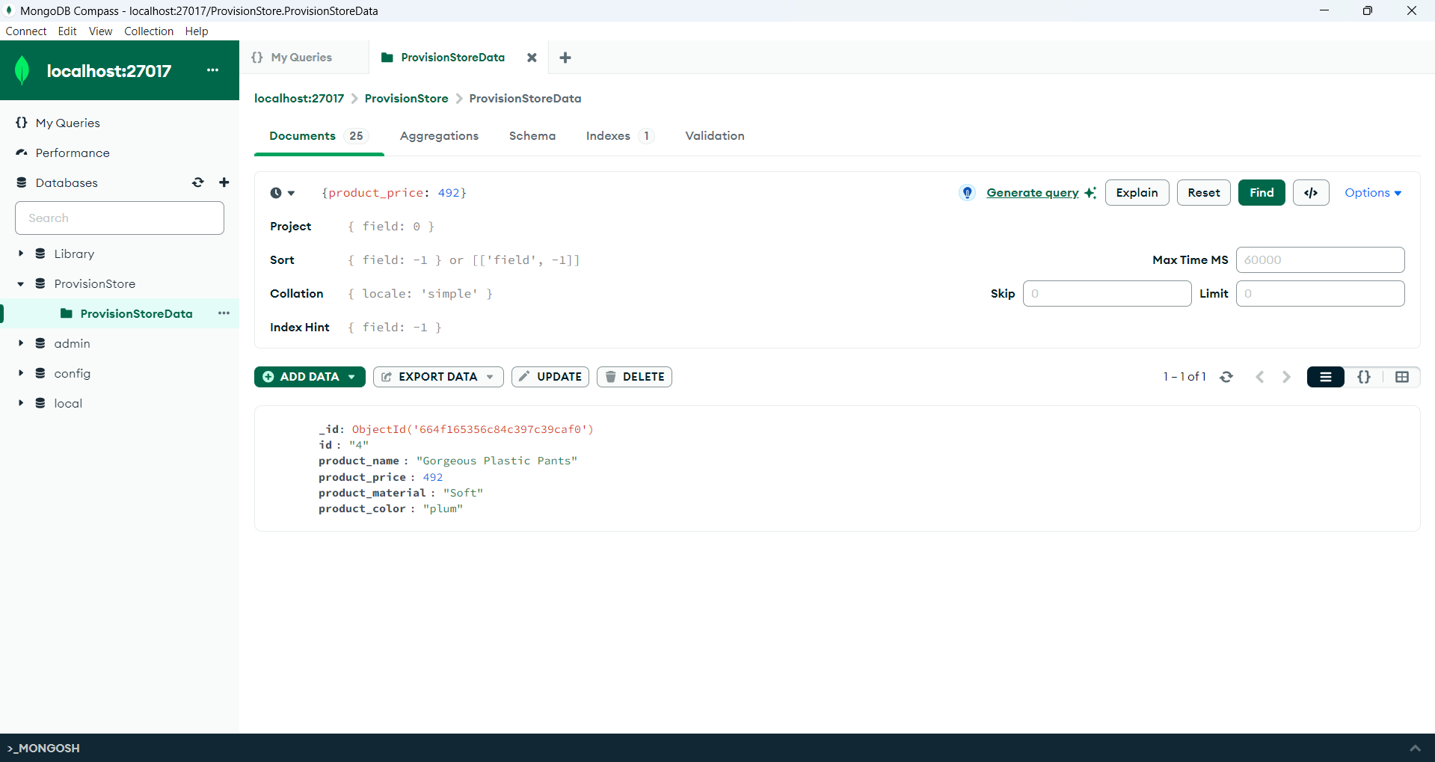

**Shell Execution:**

product color indigo

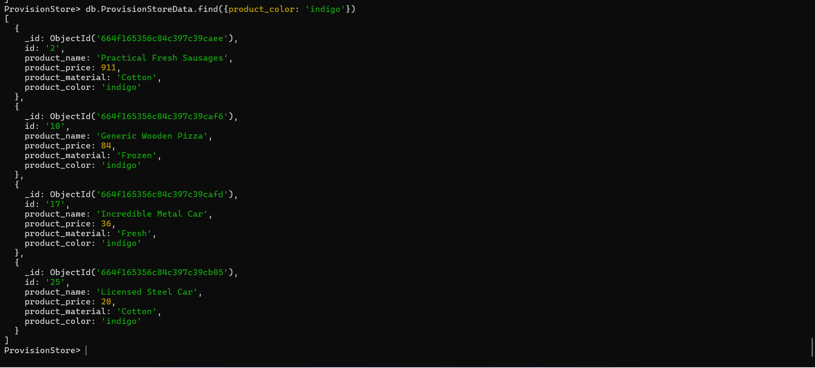

product price 492.00

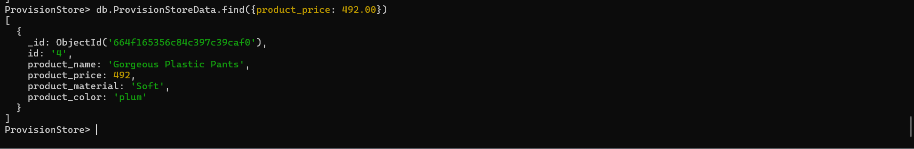

10.Delete the products which product price value are 28

Shell Execution:

